THE UGANDA INTERGOVERNMENTAL FISCAL TRANSFERS (UGIFT)
REPORT ON THE FINDINGS OF HEALTH CENTERS AND SCHOOLS IN ZOMBO DISTRICT – WEST NILE REGION
Date: 4th September, 2026

- ATYAK SEED SECONDARY SCHOOL – ZOMBO DISTRICT LOCAL GOVERNMENT (WEST NILE REGION)
Executive Summary & Verification Overview
The team reached the district headquarters and visited the CAO’s office welcomed us and introduced us to the DHO and DEO. We were taken to the procurement and finance offices to verify various school and health facility procured and purchased assets. The evaluation encompassed physical inventory verification, asset engraving compliance, functional testing of ICT and educational furniture, structural infrastructure inspection, and record-keeping verification.
Atyak Seed Secondary School is fully operational, conducting active teaching and learning activities. Notably, 100% of all delivered furniture, educational equipment, ICT hardware, and utility installations are functional and in active use.
Atyak Seed Secondary School maintains a functional and updated asset register on site. The inventory records document incoming furniture batches, ICT hardware specifications, and facility buildings, aligning well with statutory public asset management standards.
Academic and administrative operations are running smoothly. Minor ongoing construction finishing tasks on site do not impede educational delivery or pose safety risks to students and staff.
FINDINGS
All educational furniture and high-value ICT hardware supplied under UGIFT were physically verified on site and they were fully functional, operational and engraved; Most wooden desks, student chairs, lab stools, and HP desktop computers carry visible, standardized asset codes (e.g., `ATY SSS/DSK/...`):
- Wooden Desks 120 Units
- Student Chairs 170 Units
- Lab Stools 192 Units
- ICT Tables 100 Units
- HP Desktop Computers 20 Units
The building structures and utility systems constructed at Atyak Seed Secondary School are operational and actively utilized:
- Classroom Blocks - 3 Blocks (6 Classrooms total)
- Administration Block - 1 Block
- Multipurpose Hall - 1 Block
- Science Laboratory Block - 1 Block
- ICT Lab / Library Block - 1 Block (Solar Powered)
- Staff Accommodation - 3 Staff Quarters Blocks
- Sanitation Facilities - 3 Pit Latrine Blocks
- Water Supply Systems - 3 Plastic Water Tanks (5,000L)
Challenges
- Unreliable mains electricity supply and frequent grid power surges pose significant operational risks to the school's high-value ICT infrastructure. While individual Smart-UPS units are attached to desktop PCs, the core server room and main switches require broader power line stabilization.
Recommendations
- Power Surge Suppression: Install heavy-duty central voltage regulators and surge suppression systems for the ICT Laboratory, Server Room, and CCTV control center.

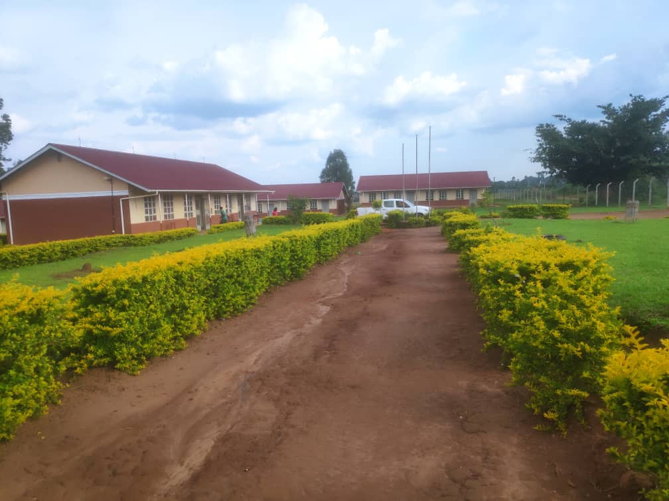
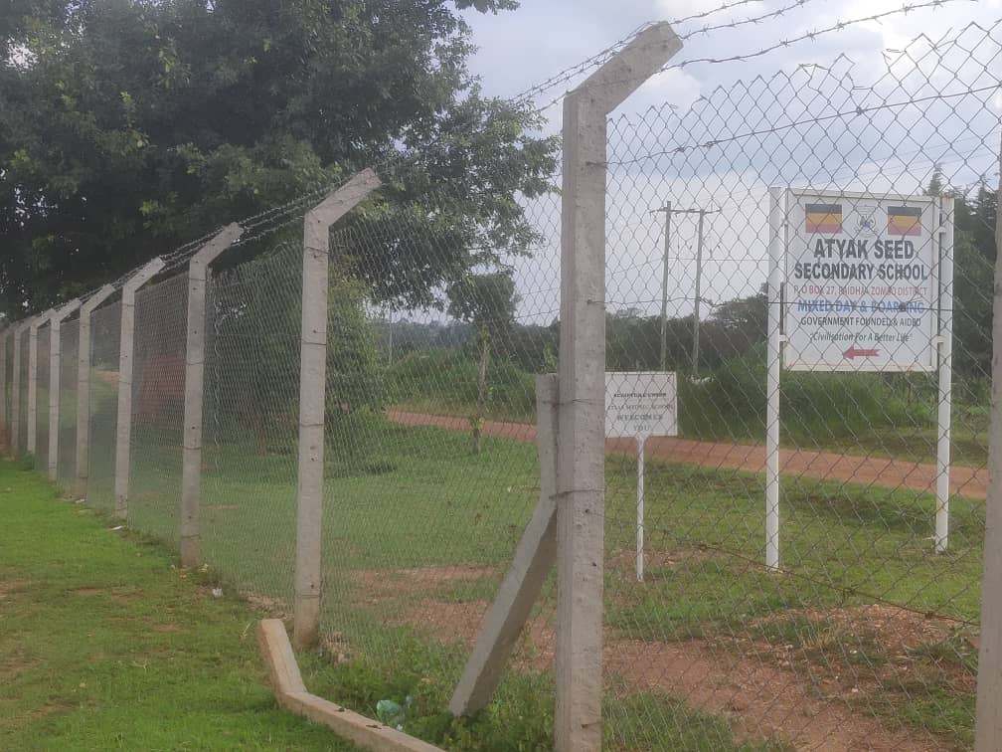
Field Photos

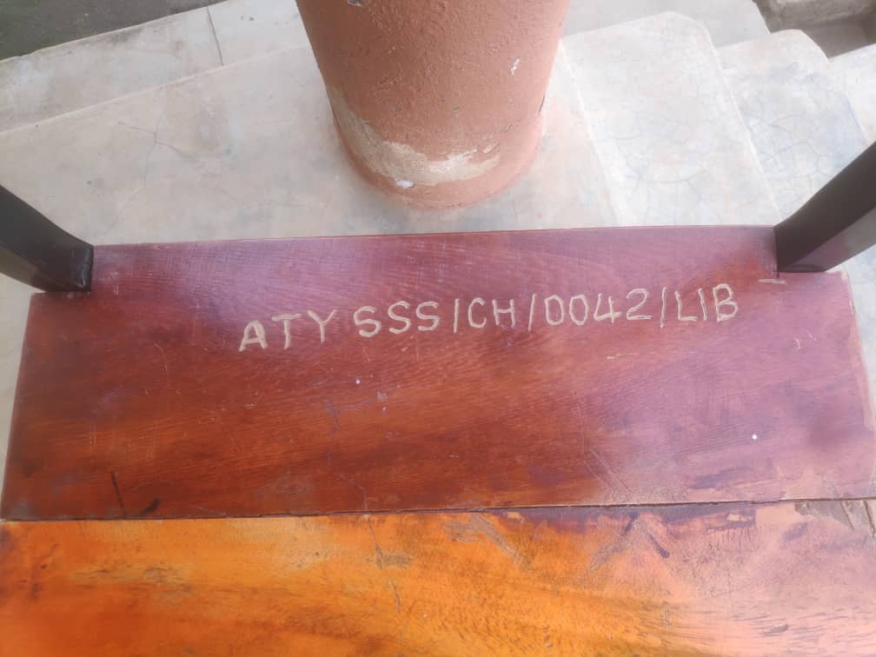
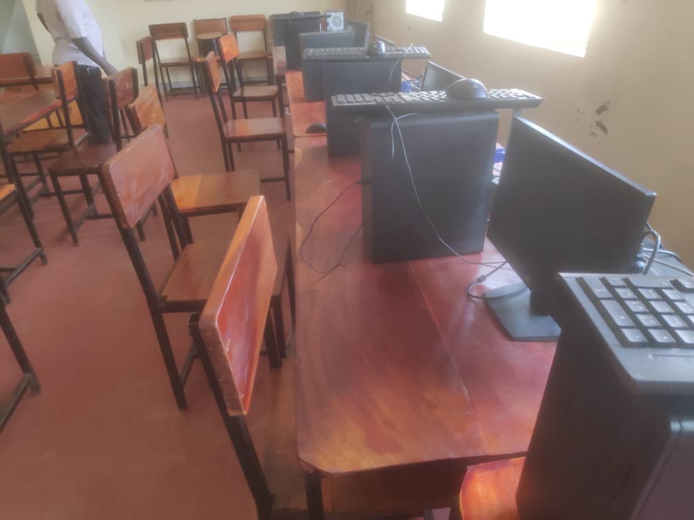

- OTHEKO HEALTH CENTRE III — ZOMBO DISTRICT LOCAL GOVERNMENT (WEST NILE REGION)
Executive Summary & Verification Overview
The objective of the audit was to verify physical asset existence, operational condition, maintenance frameworks, engraving status, and compliance with statutory record-keeping guidelines.
The health facility is fully operational and actively providing primary healthcare services to the population of Zombo District. While the majority of supplied medical equipment and civil infrastructure elements are in functional condition, the facility exhibits critical record-keeping gaps, non-functional emergency apparatus, unutilized boxed medical items, and incomplete physical asset engraving.
FINDINGS
Otheko Health Centre III does NOT maintain a complete master asset register. There are no centralized records detailing original acquisition costs, asset procurement dates, expected service lifespans, or depreciation schedules. This absence impaired asset tracking hence we were guided by the In charge to verify most of the assets physically.
MAINTENANCE & REPAIRS
Facility maintenance relies on a dual escalation path:
- Major Medical Equipment Repairs: Managed via a scheduled technical engineering team deployed from Gulu Regional Referral Hospital.
- Minor Repairs & Incidentals: Handled through local facility operational funds or escalated directly to the District Health Officer (DHO) and Chief Administrative Officer (CAO).
Physical Inventory & Medical Equipment Audit
A complete physical verification of medical apparatus, patient furniture, and ward equipment was performed. It was discovered that most of the assets are in good condition and operational whereas a few were still kept in the store and haven’t been used yet since delivery
Facility Buildings
All primary non-residential, residential, and utility structures at Otheko Health Centre III are functional and actively utilized:
- Maternity, Inpatient & Laboratory Block - 1 Non-residential Block
- Offices, OPD & Laboratory Block -1 Non-residential Block
- Staff Quarters Block - 1 Residential Block
- Gentex Water Storage Tanks - 2 Units (5,000L each)
- Sanitation Facility - 1 Block (4-stance pit latrine)
Asset Engraving
- The verification revealed widespread gaps in physical asset identification. The vast majority of functional medical apparatus, specialized equipment, patient beds, and diagnostic tools remain unengraved. The only items bearing standard physical asset tags are medical waste bins, office desks, filing cabinets, and wooden benches engraved under GOU/MOH-UGIFT PROJECT F/Y 2023/2024.
Challenges
- Power Quality & Electricity Supply Risks: The facility experiences frequent power surges, severe voltage instability, and persistent grid interruptions. Sensitive electronic medical devices—such as the Duo Flow oxygen concentrator, infant warmer, suction apparatus, and laboratory microscope—are at severe risk of electrical burnout without dedicated protection. Additionally the office chairs that were supplied were not good break easily.
Recommendations
- Power Surge Protection: Immediately procure and install dedicated high-capacity voltage regulators, surge protectors, and power stabilizers for all electronic medical equipment. The Gulu referral technical maintenance team should at least visit more often to check on various assets breakdown instead of working on their once in a while timeframe.
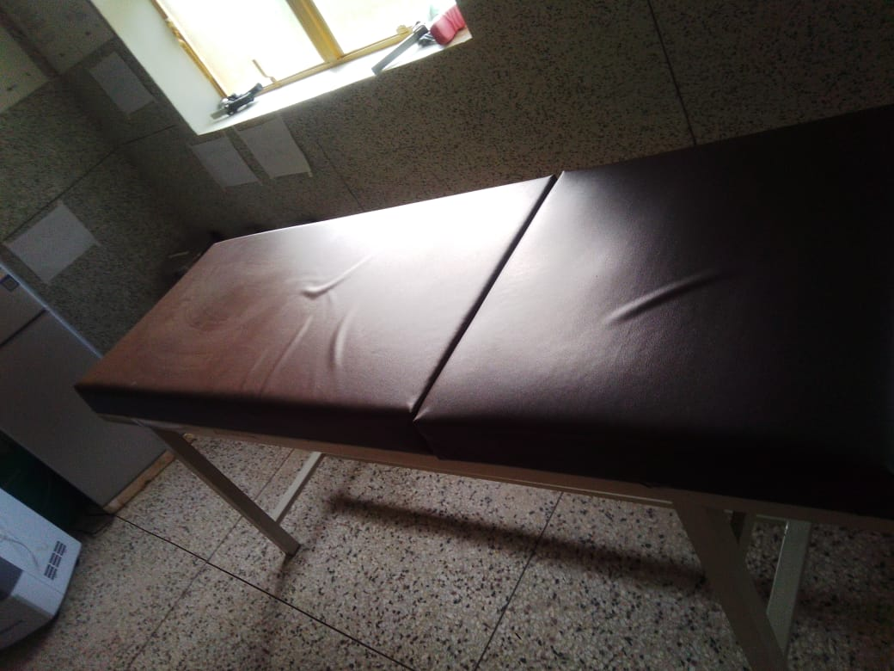
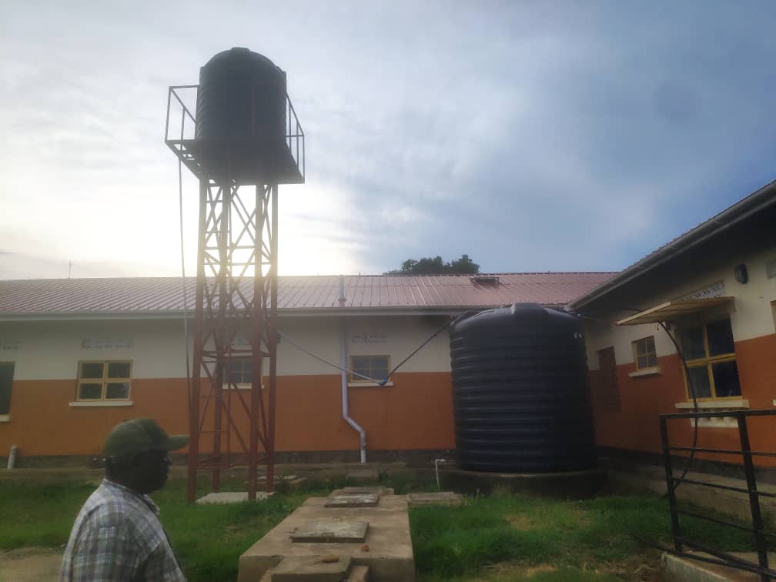
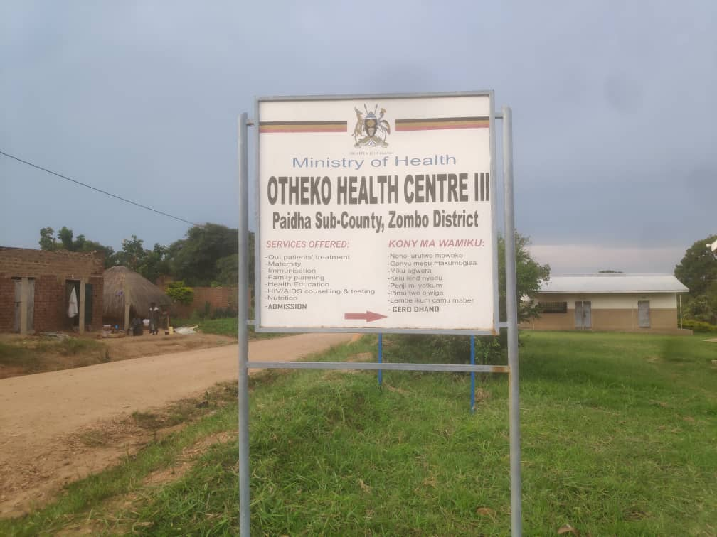
Field Photo

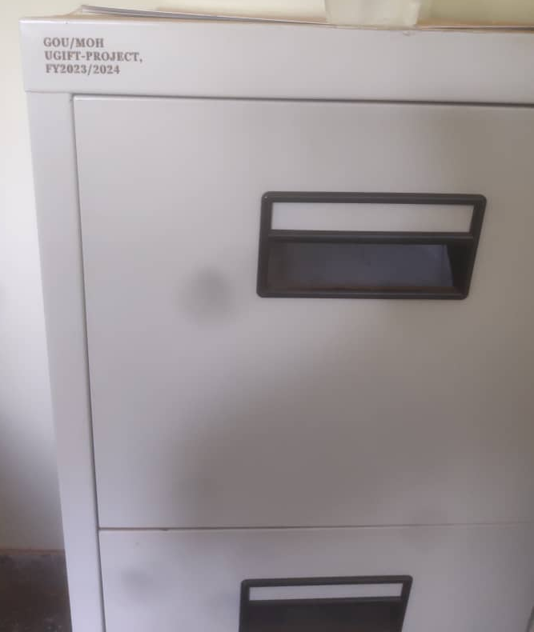
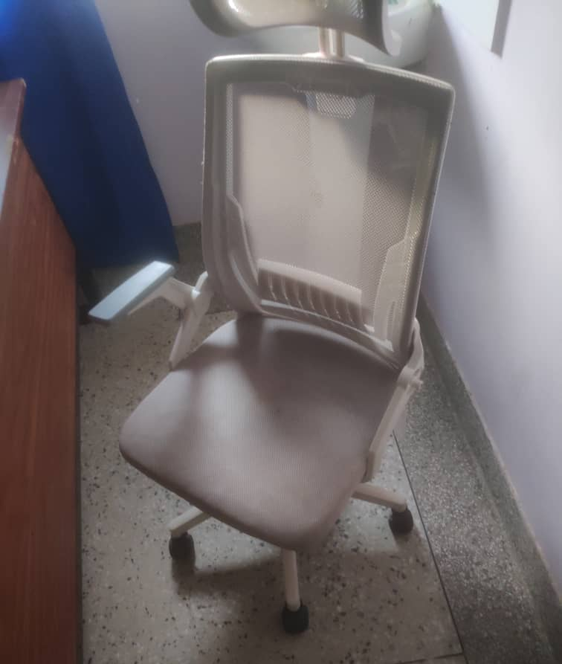
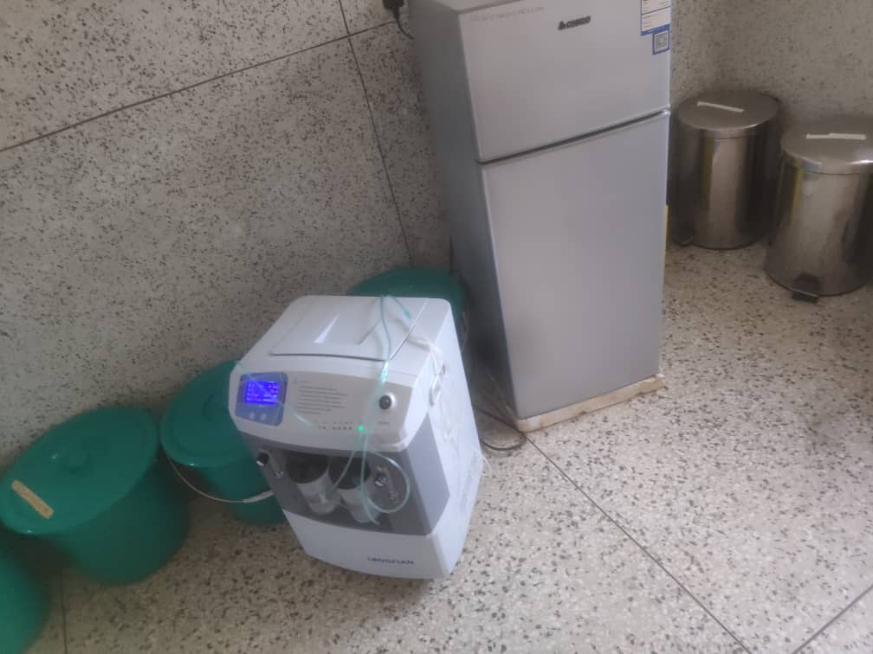

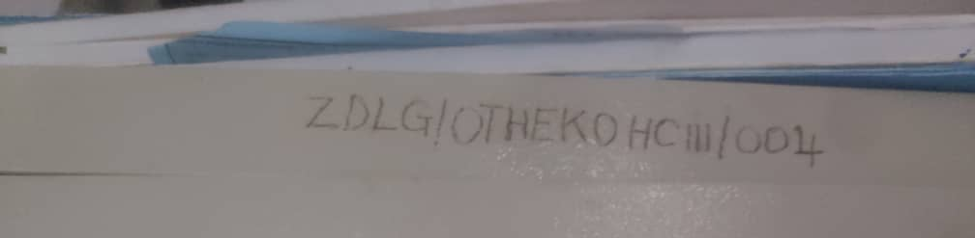

- AMEI SEED SECONDARY SCHOOL – ZOMBO DISTRICT LOCAL GOVERNMENT (WEST NILE REGION)
Executive Summary
This field verification report presents a comprehensive summary and critical asset audit for Amei Seed Secondary School, located in Paidha Sub-County, Zombo District Local Government. The evaluation was conducted under the Uganda Intergovernmental Fiscal Transfers (UgIFT) Program framework to assess infrastructure delivery, asset verification, hardware functionality, and operational readiness.
Overall, the construction of core non-residential infrastructure—including classroom blocks, administration offices, a multipurpose hall, science laboratory, and ICT/library block—is physically completed and equipped with standard school furniture. However, full operationalization and commissioning are severely hindered by key ongoing construction gaps, uninstalled civil assets, and off-site hardware storage.
FINDINGS
- Total Furniture Verified - 672 Units
- Total ICT Hardware Verified - 63 Units, – Still at the district office store boxed
- Completed Academic Blocks - 5 Blocks
- Residential Staff Quarters remain under construction - Incomplete Staff Quarters - 3 Units
Comprehensive Verified Assets Inventory
The physical audit categorized all delivered and planned assets into three primary groups: School Furniture, ICT Equipment, and Buildings/Infrastructure. Each item was inspected for quantity, tagging/engraving compliance, functional status, and deployment status.
School Furniture Inventory
A total of 672 furniture units were verified on site across the completed classroom and administration blocks. All furniture items are currently un-engraved ('Not engraved').
Item Description | Qty
Wooden School Desks | 120
Office Tables | 15
Student Chairs | 232
Office Chairs | 34
Students' Tables | 126
Laboratory Stools | 124
Book Shelves | 21
ICT Equipment & Infrastructure Inventory
A total of 63 physical ICT hardware units, along with a Local Area Network (LAN) installation and a 12-month Internet subscription, were procured under UgIFT. All items were purchased on 29/07/2025. However, 100% of the physical hardware remains stored in boxes at the Zombo District Store awaiting school construction completion and security commissioning.
Equipment Item | Qty | Storage / Deployment Remarks
HP Desktop Computer with Display Monitor | 20 | Still boxed at District store
Server Processor | 1 | Still boxed at District store
Power Surge Protectors | 10 | Still boxed at District store
Network Switch (24 Ports, Hikvision PoE) | 2 | Still boxed at District store
Multipurpose Printer | 1 | Still boxed at District store
Server UPS | 1 | Still boxed at District store
APC Smart UPS (SMT7501-CH) | 20 | Still boxed at District store
Digital Projector | 1 | Still boxed at District store
Outdoor Unit Air Conditioner | 1 | Still boxed at District store
CCTV Camera | 1 | Still boxed at District store
Network Firewall | 1 | Still boxed at District store
Network Rack Cabinet | 1 | Still boxed at District store
Network Router | 1 | Still boxed at District store
Wireless Router | 1 | Still boxed at District store
Local Area Network (LAN) Setup | 1 | Still boxed at District store
12 Months Internet Connection | 12 Mos | Accounted for; awaiting building completion
3.3 Buildings & Infrastructure Verification
Infrastructure verification examined all academic, administrative, residential, sanitation, and water utility structures. Academic blocks are fully constructed and furnished, whereas residential staff quarters and water storage assets are lagging behind.
Infrastructure / Asset Item | Scope & Description | Operational & Civil Works Remarks
Classroom Blocks (3 Blocks) | 3 blocks x 2 classrooms each (6 classrooms total) | Completed; classroom furniture installed
Administration Block | 1 block with offices and staffroom | Completed; office furniture installed
Multipurpose Building | 1 main hall block (~3 classroom capacity) | Completed; furniture installed
Science Laboratory Block | 1 laboratory block with 2 lab rooms | Completed; furniture installed
ICT Laboratory & Library Block | 1 combined ICT/Library block with solar power | Completed; furniture installed
Administration Pit Latrine | 1 dedicated staff latrine block | Completed and actively in use
Girl Students' Pit Latrine | 1 female student sanitation block | Completed and actively in use
Boy Students' Pit Latrine | 1 male student sanitation block | Completed and actively in use
Staff Quarters (3 Residential Blocks) | 3 residential staff units with kitchen & latrine | Incomplete; still actively under construction
Plastic Water Storage Tanks | 3 plastic water tanks (5,000 Liters capacity each) | Delivered but not yet installed/connected

Field Discussion & Program Implementation Analysis
During the field audit, structured interviews and discussions were conducted with facility stakeholders and district representatives. The key findings regarding records, maintenance, service impact, and implementation challenges are detailed below:
- The facility maintains an organized record of all assets provided under the UgIFT program, including delivery notes and asset classifications.
- The facility is still actively under construction and has not been fully commissioned. Staff quarters remain unfinished. Consequently, full maintenance, repair, and replacement protocols are yet to be operationalized.
- The school maintains regular monitoring logs regarding asset functionality and breakdown status. No operational breakdowns were reported, though several assets remain non-functional due to delayed installation.
Program Impact
- Transformative Impact: Once completed and commissioned, Amei Seed SS will establish a state-of-the-art rural academic hub featuring modern science laboratories, staff housing, ICT facilities, and sanitation blocks, revolutionizing local secondary education.
Challenges
- Major construction delays stem from assigning the SAME CONTRACTOR to concurrently execute works at both Amei Seed SS and Kango Seed SS. This concurrency split the contractor's capacity, directly delaying ICT and science lab equipment installation.
Recommendations
- Timely release of government funds is required to ensure smooth cash flow and enable the contractor to finish civil works. This will enable the contractor to clear liquidity bottlenecks and complete the 3 staff quarters and water tank mountings.
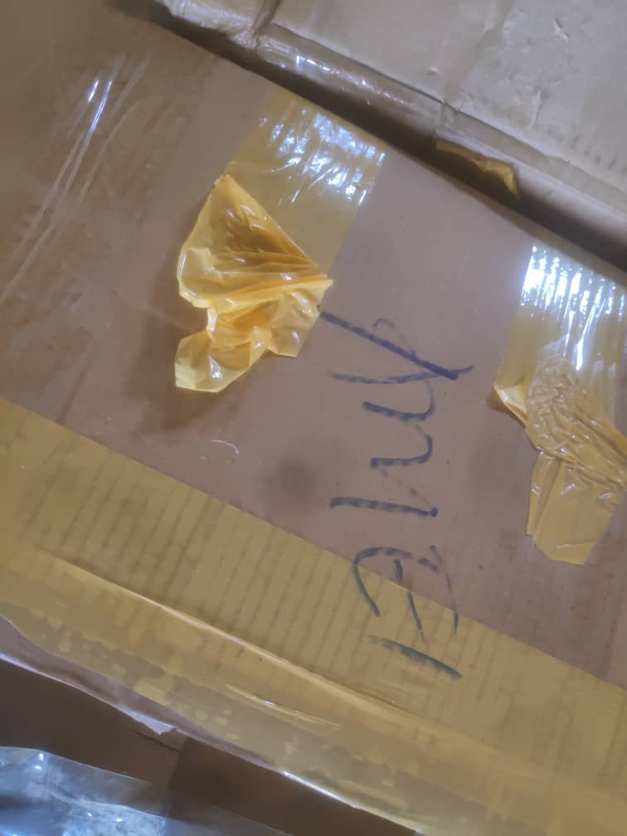
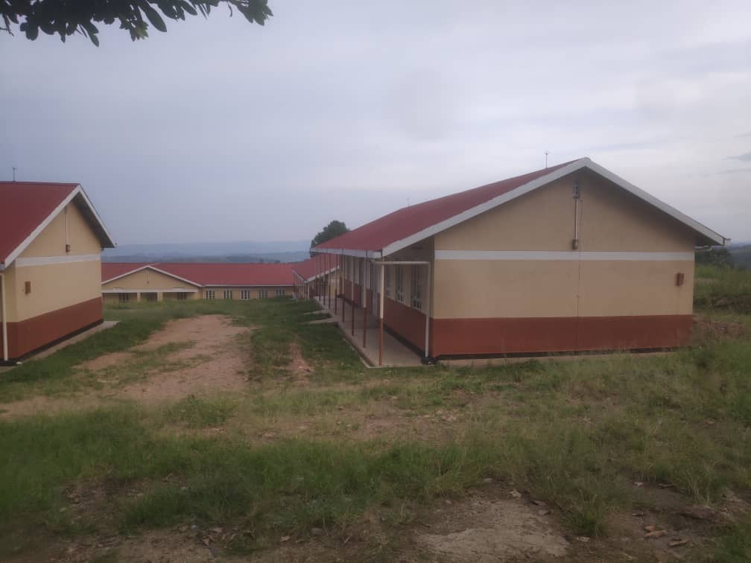
Field photos
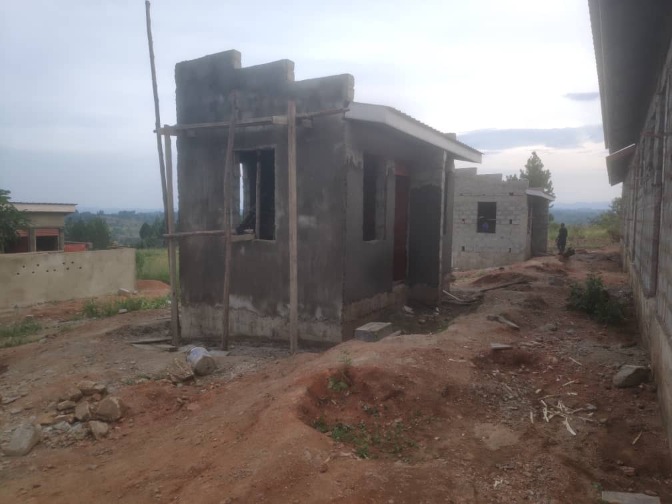

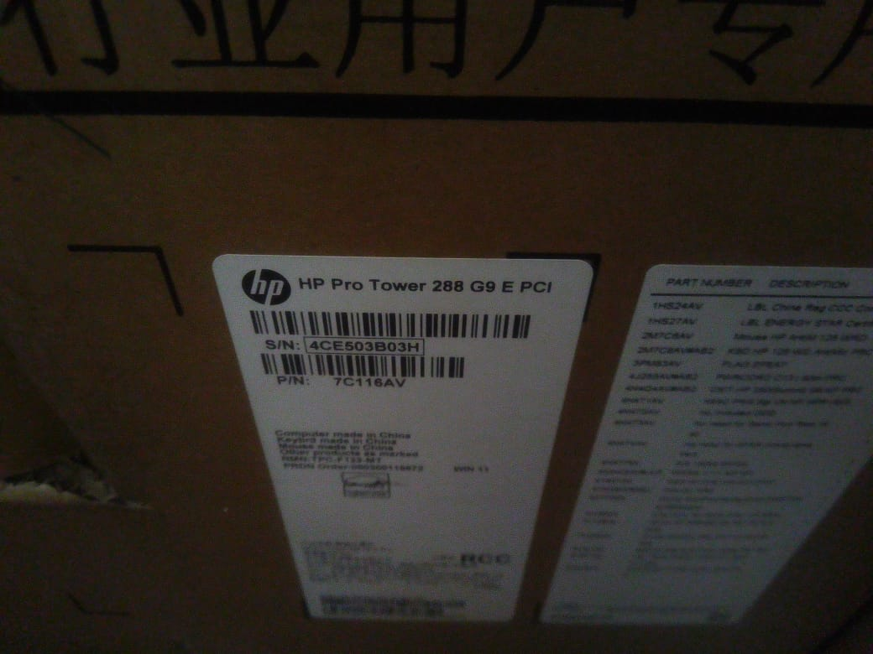
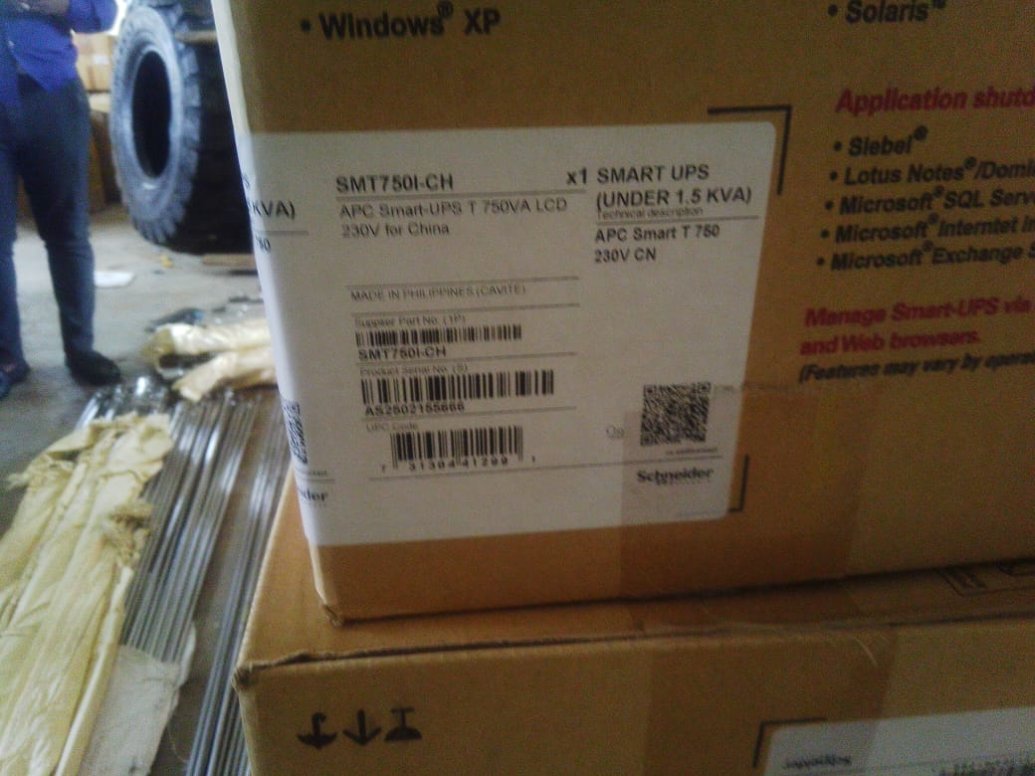
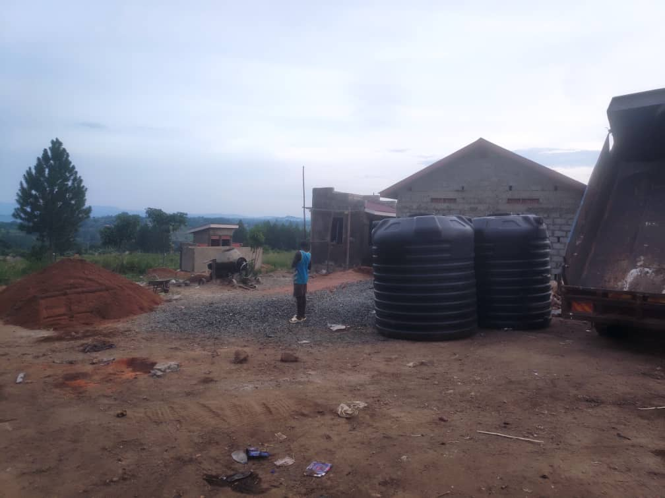

- KANGO SEED SECONDARY SCHOOL – ZOMBO DISTRICT LOCAL GOVERNMENT (WEST NILE REGION)
Executive Summary
This field verification report presents a comprehensive summary and critical asset audit for Kango Seed Secondary School, located in Kango Sub-County, Zombo District Local Government. The evaluation was conducted under the Uganda Intergovernmental Fiscal Transfers (UgIFT) Program framework to assess infrastructure delivery, asset verification, hardware functionality, and operational readiness.
Overall, the construction of core non-residential infrastructure—including classroom blocks, administration offices, a multipurpose hall, science laboratory, and ICT/library block—is physically completed and equipped with standard school furniture. However, full operationalization and commissioning are severely hindered by key ongoing construction gaps, uninstalled civil assets, and off-site hardware storage.
FINDINGS
- Total Furniture Verified - 672 Units
- Total ICT Hardware Verified - 63 Units, – Still at the district office store boxed
- Completed Academic Blocks - 5 Blocks
- Residential Staff Quarters remain under construction - Incomplete Staff Quarters - 3 Units
Comprehensive Verified Assets Inventory
The physical audit categorized all delivered and planned assets into three primary groups: School Furniture, ICT Equipment, and Buildings/Infrastructure. Each item was inspected for quantity, tagging/engraving compliance, functional status, and deployment status.
School Furniture Inventory
A total of 672 furniture units were verified on site across the completed classroom and administration blocks. All furniture items are currently un-engraved ('Not engraved').
Item Description | Qty
Wooden School Desks | 120
Office Tables | 15
Student Chairs | 232
Office Chairs | 34
Students' Tables | 126
Laboratory Stools | 124
Book Shelves | 21
ICT Equipment & Infrastructure Inventory
A total of 63 physical ICT hardware units, along with a Local Area Network (LAN) installation and a 12-month Internet subscription, were procured under UgIFT. All items were purchased on 29/07/2025. However, 100% of the physical hardware remains stored in boxes at the Zombo District Store awaiting school construction completion and security commissioning.
Equipment Item | Qty | Storage / Deployment Remarks
HP Desktop Computer with Display Monitor | 20 | Still boxed at District store
Server Processor | 1 | Still boxed at District store
Power Surge Protectors | 10 | Still boxed at District store
Network Switch (24 Ports, Hikvision PoE) | 2 | Still boxed at District store
Multipurpose Printer | 1 | Still boxed at District store
Server UPS | 1 | Still boxed at District store
APC Smart UPS (SMT7501-CH) | 20 | Still boxed at District store
Digital Projector | 1 | Still boxed at District store
Outdoor Unit Air Conditioner | 1 | Still boxed at District store
CCTV Camera | 1 | Still boxed at District store
Network Firewall | 1 | Still boxed at District store
Network Rack Cabinet | 1 | Still boxed at District store
Network Router | 1 | Still boxed at District store
Wireless Router | 1 | Still boxed at District store
Local Area Network (LAN) Setup | 1 | Still boxed at District store
12 Months Internet Connection | 12 Mos | Accounted for; awaiting building completion
3.3 Buildings & Infrastructure Verification
Infrastructure verification examined all academic, administrative, residential, sanitation, and water utility structures. Academic blocks are fully constructed and furnished, whereas residential staff quarters and water storage assets are lagging behind.
Infrastructure / Asset Item | Scope & Description | Operational & Civil Works Remarks
Classroom Blocks (3 Blocks) | 3 blocks x 2 classrooms each (6 classrooms total) | Completed; classroom furniture installed
Administration Block | 1 block with offices and staffroom | Completed; office furniture installed
Multipurpose Building | 1 main hall block (~3 classroom capacity) | Completed; furniture installed
Science Laboratory Block | 1 laboratory block with 2 lab rooms | Completed; furniture installed
ICT Laboratory & Library Block | 1 combined ICT/Library block with solar power | Completed; furniture installed
Administration Pit Latrine | 1 dedicated staff latrine block | Completed and actively in use
Girl Students' Pit Latrine | 1 female student sanitation block | Completed and actively in use
Boy Students' Pit Latrine | 1 male student sanitation block | Completed and actively in use
Staff Quarters (3 Residential Blocks) | 3 residential staff units with kitchen & latrine | Incomplete; still actively under construction
Plastic Water Storage Tanks | 3 plastic water tanks (5,000 Liters capacity each) | Delivered but not yet installed/connected
Field Discussion & Program Implementation Analysis
During the field audit, structured interviews and discussions were conducted with facility stakeholders and district representatives. The key findings regarding records, maintenance, service impact, and implementation challenges are detailed below:
- The facility maintains an organized record of all assets provided under the UgIFT program, including delivery notes and asset classifications.
- The facility is still actively under construction and has not been fully commissioned. Staff quarters remain unfinished. Consequently, full maintenance, repair, and replacement protocols are yet to be operationalized.
- The school maintains regular monitoring logs regarding asset functionality and breakdown status. No operational breakdowns were reported, though several assets remain non-functional due to delayed installation.
Program Impact
- Transformative Impact: Once completed and commissioned, Kango Seed SS will establish a state-of-the-art rural academic hub featuring modern science laboratories, staff housing, ICT facilities, and sanitation blocks, revolutionizing local secondary education.
Challenges
- Major construction delays stem from assigning the SAME CONTRACTOR to concurrently execute works at both Kango Seed SS and Amei Seed SS. This concurrency split the contractor's capacity, directly delaying ICT and science lab equipment installation.
Recommendations
- Timely release of government funds is required to ensure smooth cash flow and enable the contractor to finish civil works. This will enable the contractor to clear liquidity bottlenecks and complete the 3 staff quarters and water tank mountings.
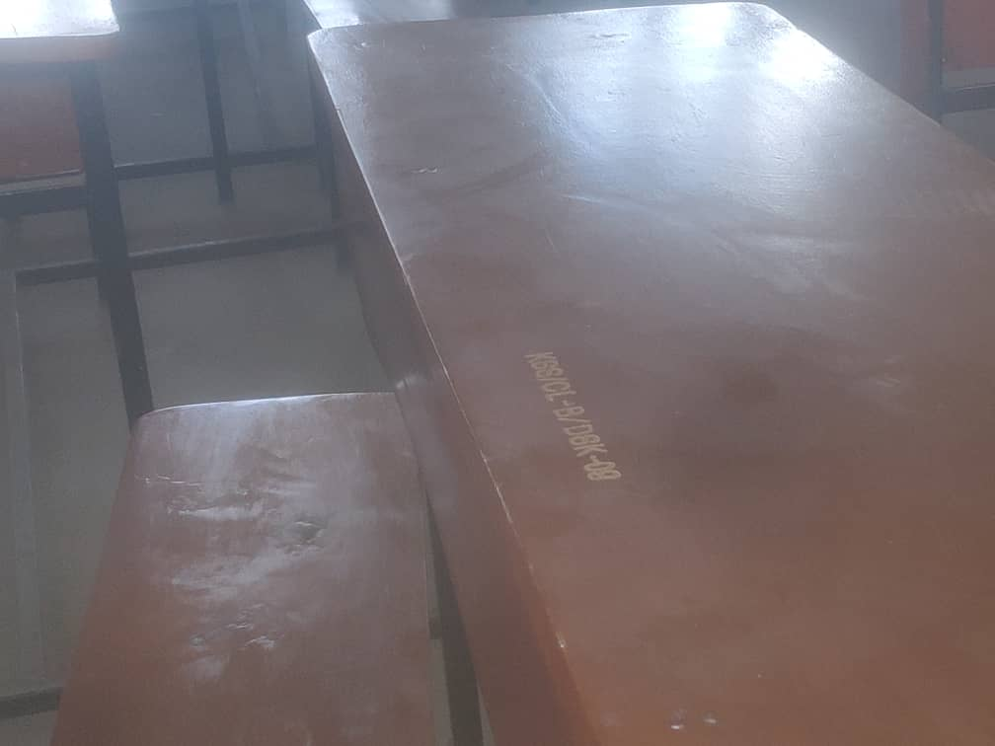
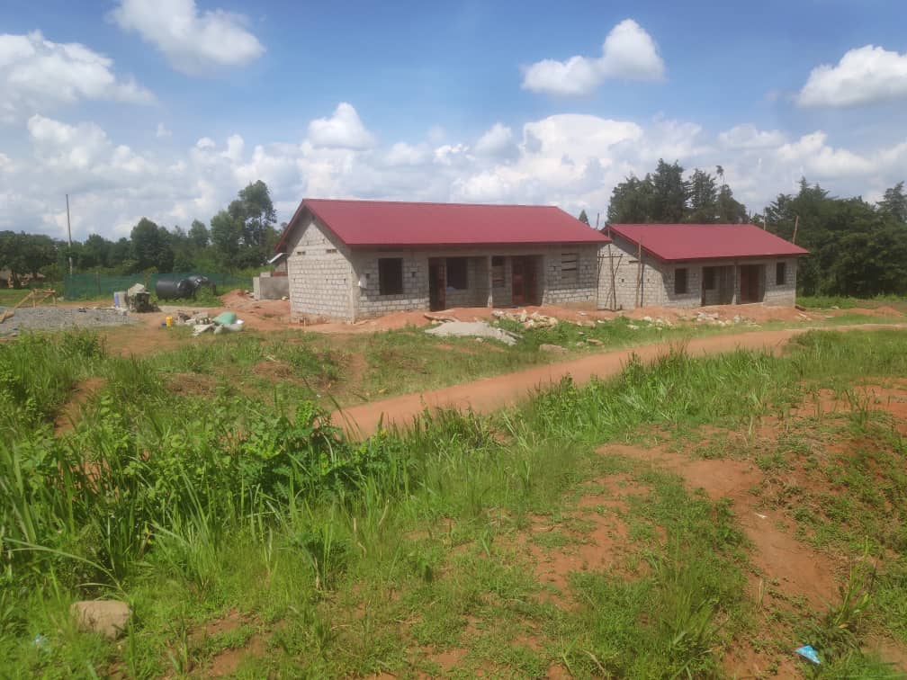
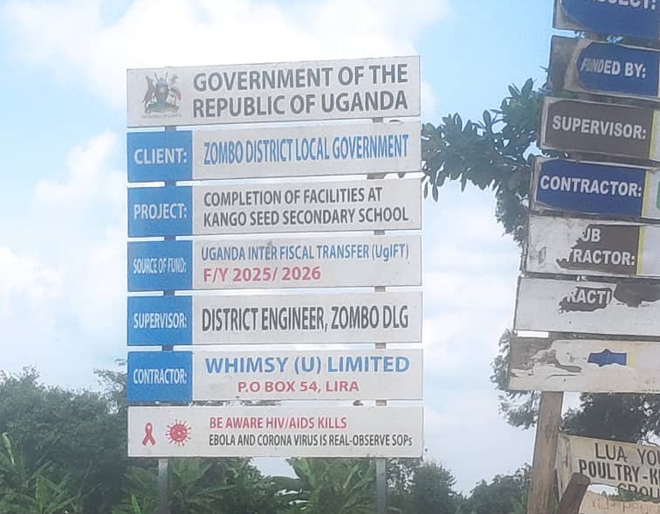
Field photos

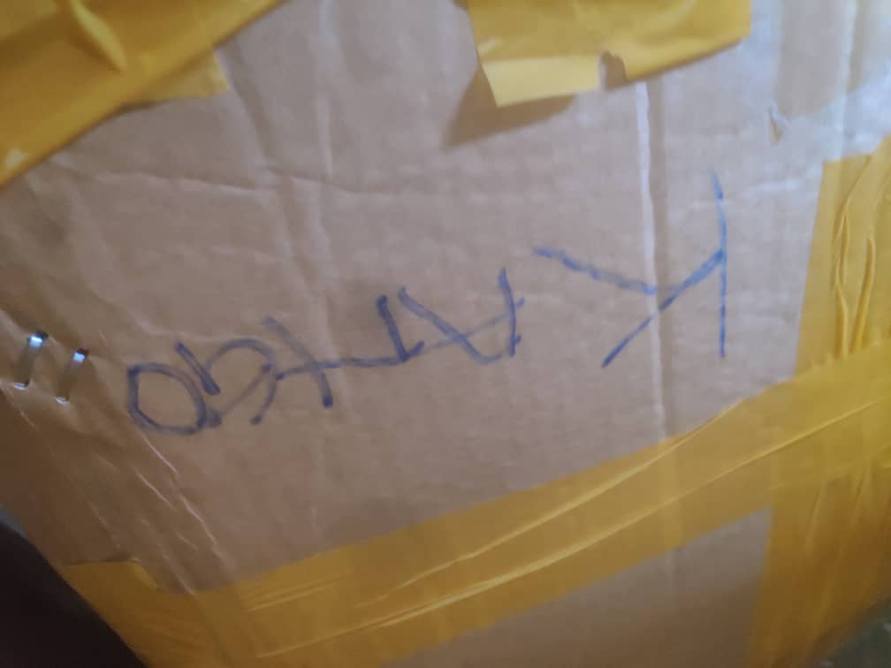
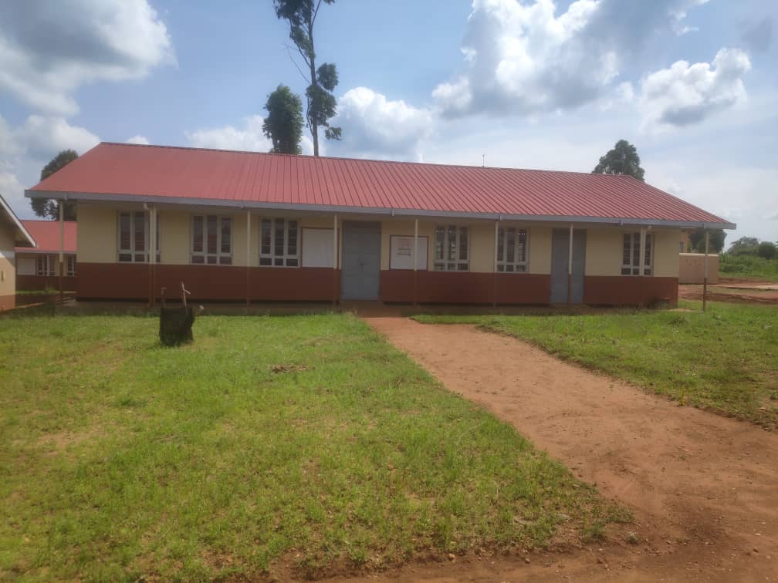
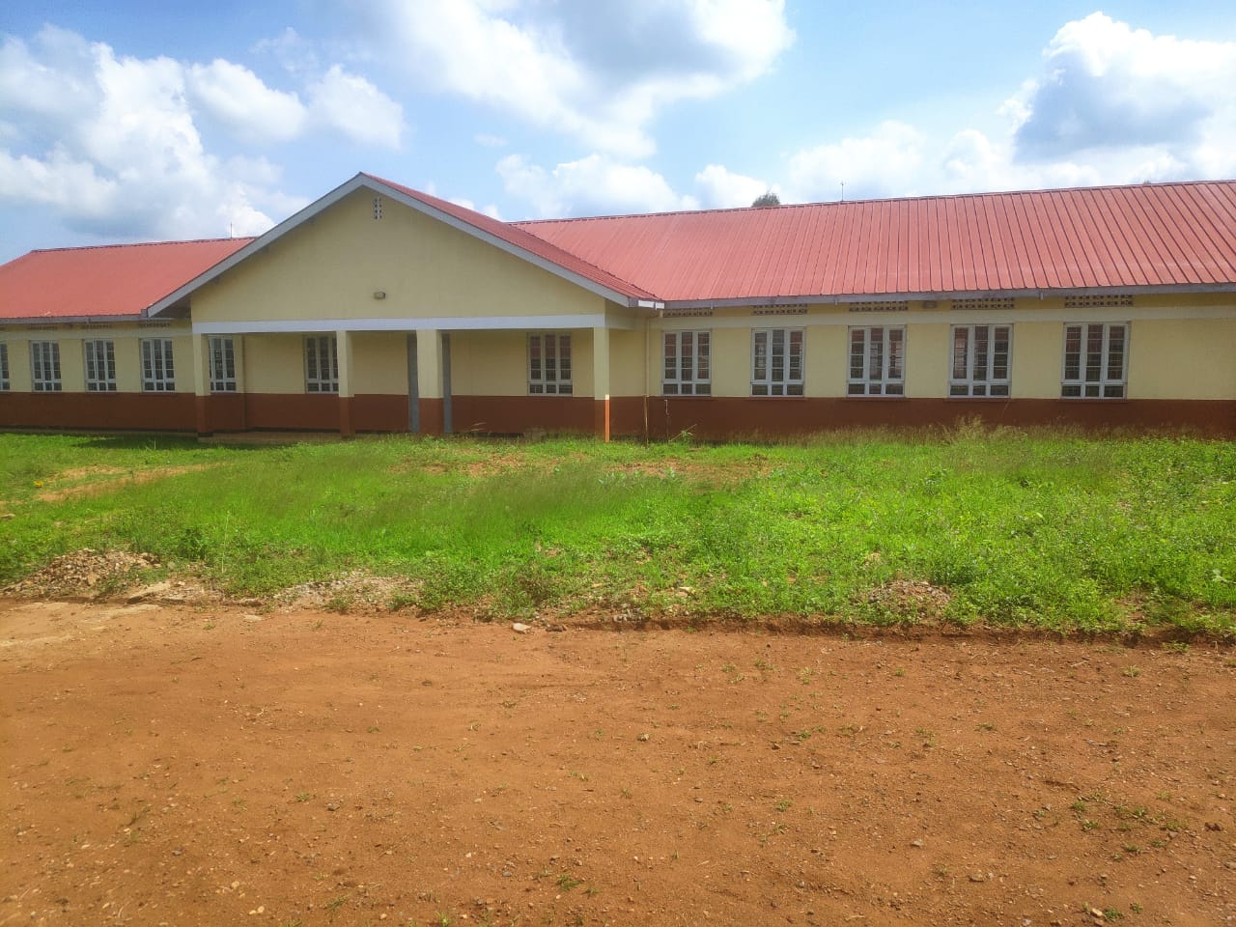

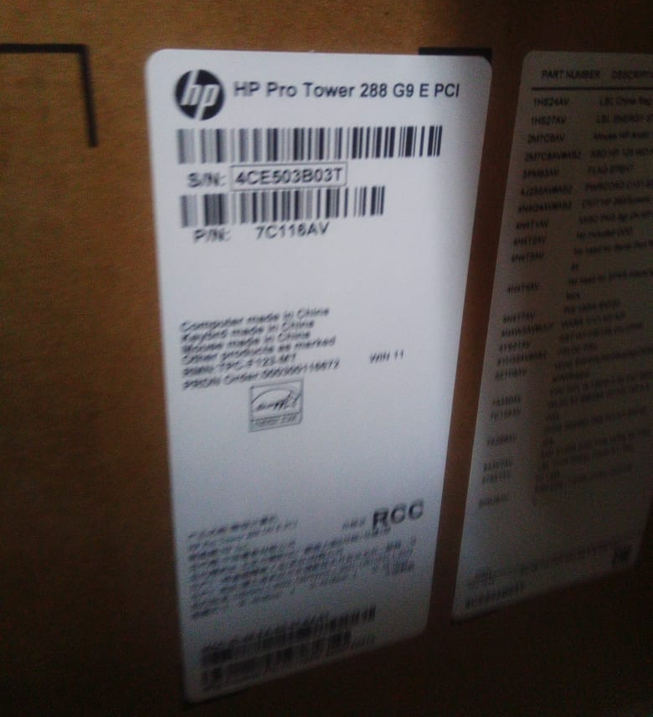
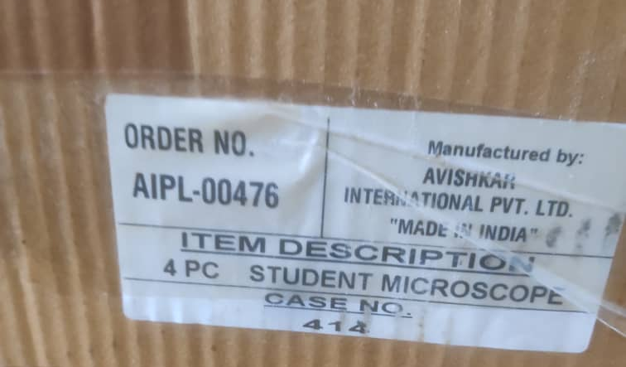
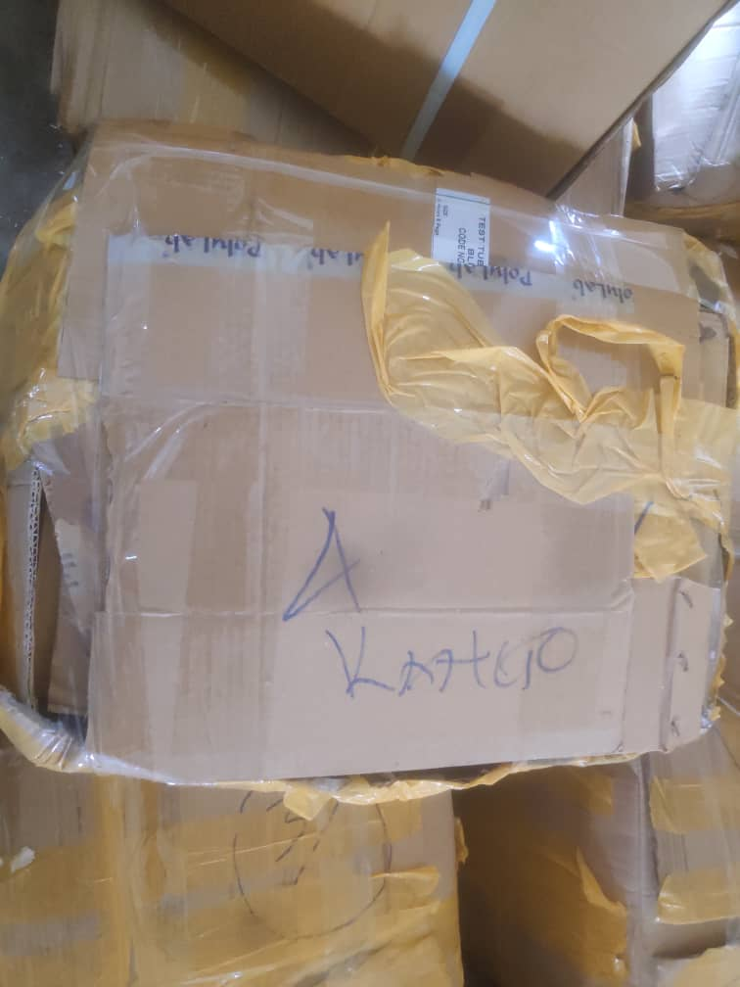

- AMWONYO HC III — ZOMBO DISTRICT LOCAL GOVERNMENT (WEST NILE REGION)
Executive Summary
This report presents the comprehensive audit findings and verified asset inventory for Amwonyo Health Centre III located in Akaa Sub-County, Zombo District, following a detailed field verification exercise conducted between August and September 2026.
Out of 54 distinct asset line items and civil infrastructure projects audited at Amwonyo HC III, 52 items (96.3%) are functional. UgIFT investments have dramatically expanded clinical bed capacity and patient admissions. However, severe power supply instability and non-functional solar systems have left heavy diagnostic equipment (including autoclaves, centrifuges, and refrigerators) stored in original packaging.

Note: During physical inspection, the field team identified 22 equipment categories present and operational on-site that were not recorded on the official UgIFT master list. These items include wall-mounted BP machines, examination couches, LED examination lights, height meters, binocular microscopes, patient screens, stethoscopes, stretchers, adult weighing scales, digital infant weighing scales, wheelchairs, medical waste bins, wall clocks, adult beds, benches, oxygen concentrators, centrifuges, infant warmers, delivery beds, swivel office chairs, desks, and filing cabinets. All these items were physically verified, inspected, by the guidance of the in-charge and integrated into this master summary.
Findings
- Physical Provision: High Rate of Asset Availability & Operationality: Over 96% of supplied UgIFT assets were physically accounted for on-site, in functional physical condition, and actively enhancing patient care.
- Service Delivery Impact: The introduction of UgIFT medical equipment (maternity beds, patient beds, delivery sets, resuscitators, oximeters, and suction units) has enabled full inpatient admission capacity, easing clinical workflows and significantly improving maternal and child health outcomes.
- Power Grid & Energy Bottlenecks: Frequent electricity outages and a non-functional facility solar power system prevent the deployment of electrical medical devices. Highly critical equipment—such as the 20L Autoclave, Binocular Microscope, Basic Medical Refrigerator, and Electric Centrifuge—remains packed in store boxes.
- Engraving & Tagging Compliance: The vast majority of physical assets lack official engraved asset tags. Only wooden/metallic benches, desks, filing cabinets, and waste bins carry project markings ('GOU/MOH-UGIFT PROJECT F/Y 2023/2024'). Unengraved items present high risk for asset management and tracking.
- Oxygen Refill Logistics Deficit: Two 45L Oxygen Therapy Apparatus cylinders were verified as non-functional due to lack of medical oxygen refills, restricting emergency respiratory care.
Facility Buildings
All primary non-residential, residential, and utility structures at Amwonyo Health Centre III are functional and actively utilized:
- Maternity, Inpatient & Laboratory Block - 1 Non-residential Block
- Offices, OPD & Laboratory Block -1 Non-residential Block
- Staff Quarters Block - 1 Residential Block
- Gentex Water Storage Tanks - 2 Units (5,000L each)
- Sanitation Facility - 1 Block (4-stance pit latrine)
Qualitative Field Assessment
A structured informant interview was conducted with the In-Charge and responsible facility staff at Amwonyo Health Centre III to evaluate asset management protocols, maintenance systems, breakdown logging, and operational impact.
Asset Register & Documentation Practices
The facility maintains a physical log of assets supplied under UgIFT, detailing item counts and description details. However, the facility's asset register lacks essential financial parameters, including unit purchase costs, accumulated depreciation, net book values, and unique individual asset tag numbers. Historical procurement documentation is managed centrally at the District level, leaving local facility managers without complete asset valuation records.
Repair & Maintenance
The facility conducts regular physical checks on asset functionality. Any equipment breakdown or defect is documented and formally communicated to the DHO office. This escalation workflow ensures that defective assets are brought to district attention, though repair lead times remain constrained by regional schedule availability. Asset maintenance and repair operates under a dual-tier arrangement:
- Heavy Medical Machinery: Technical maintenance for complex, heavy medical equipment is provided by a specialized regional technical team stationed at Arua Regional Referral Hospital. However, repairs are executed according to the referral hospital's scheduled visits rather than immediate facility demand.
- Minor Equipment & Local Interventions: Minor repairs and routine equipment servicing are managed directly by the facility using primary operating funds. When repairs exceed local technical or financial capacity, issues are escalated to the District Health Officer (DHO) for guidance and funding.
Impact of UgIFT Interventions
- Eased Clinical Workflows: The availability of specialized clinical equipment (e.g., delivery beds, resuscitation kits, pulse oximeters, MCH sets) has dramatically simplified diagnostic and treatment processes.
- Expanded Inpatient Capacity: Inpatient bed capacity has expanded to full occupancy, significantly increasing total patient traffic and enabling the health centre to handle acute medical and maternal cases locally.
- Improved Quality of Care: Enhanced facilities have restored community confidence in the health centre, leading to improved primary health outcomes across Akaa Sub-County.
Challenges
The facility in-charge highlighted key operational constraints along with facility recommendations:
- Power grid instability and solar power failure represent the primary operational bottleneck. Most electrical medical equipment cannot be utilized reliably.
- Medical staff require comprehensive orientation and specialized training on operating newly supplied electronic diagnostic and laboratory equipment.
Recommendations
- Urgent technical intervention is required to fix the facility solar system and stabilize electrical supply, ensuring continuous utilization of electric medical devices. In addition, provision of a dedicated generator or stabilized grid connection is necessary to power store-bound diagnostic equipment (Autoclave, Refrigerator, Centrifuge, and Microscope).
- Need to refill the empty 45L oxygen cylinders promptly, guaranteeing emergency oxygen availability for pediatric and adult patients.
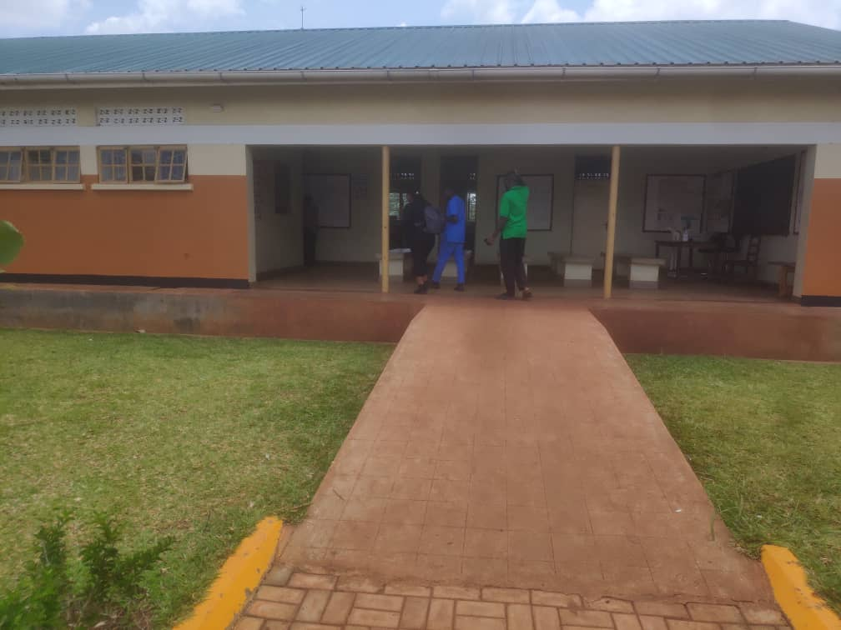
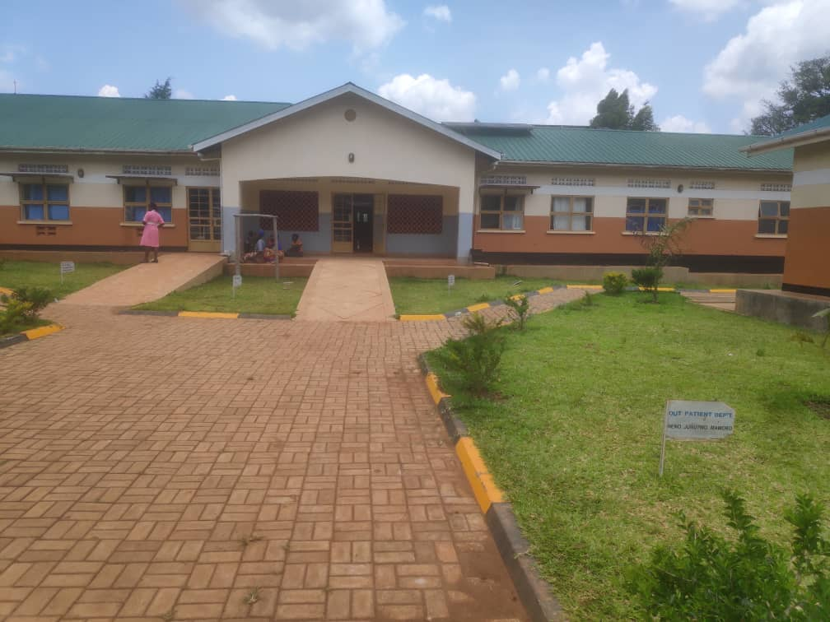
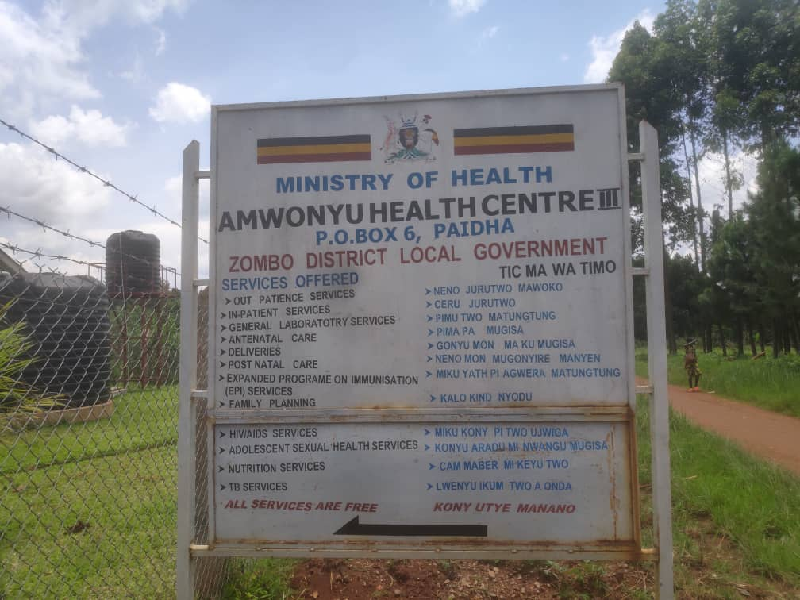
Field photos

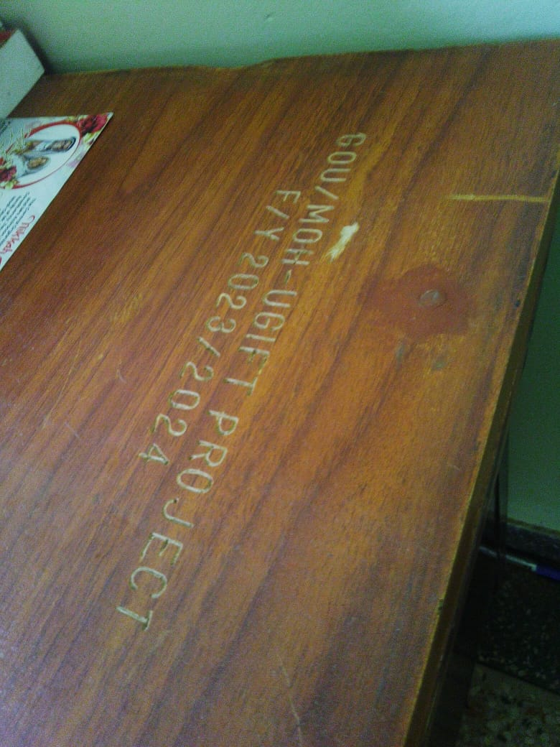
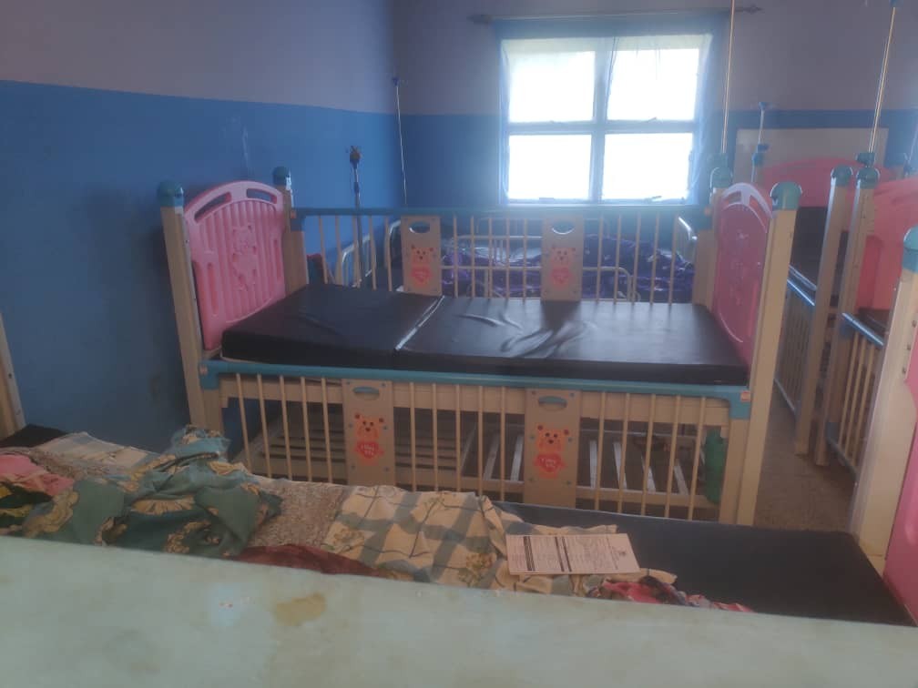
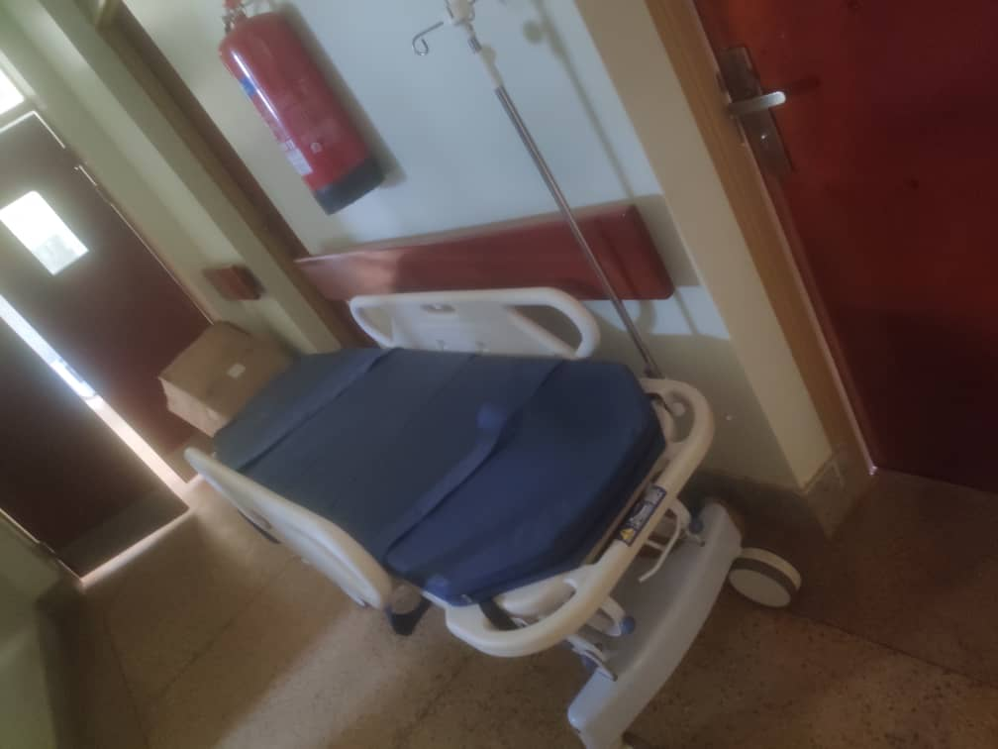

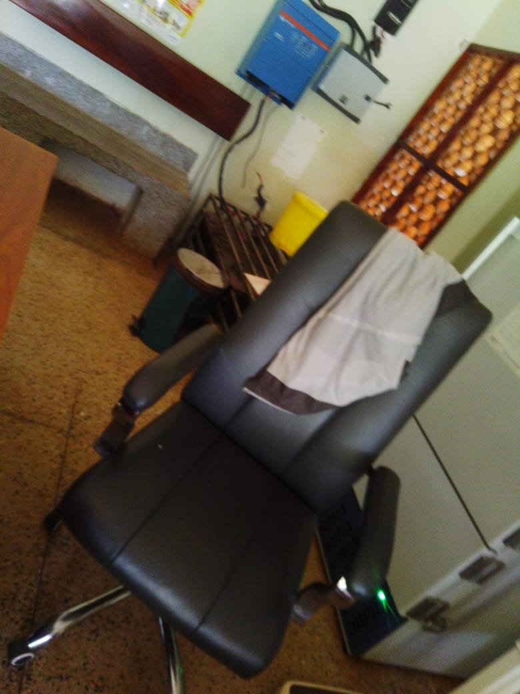
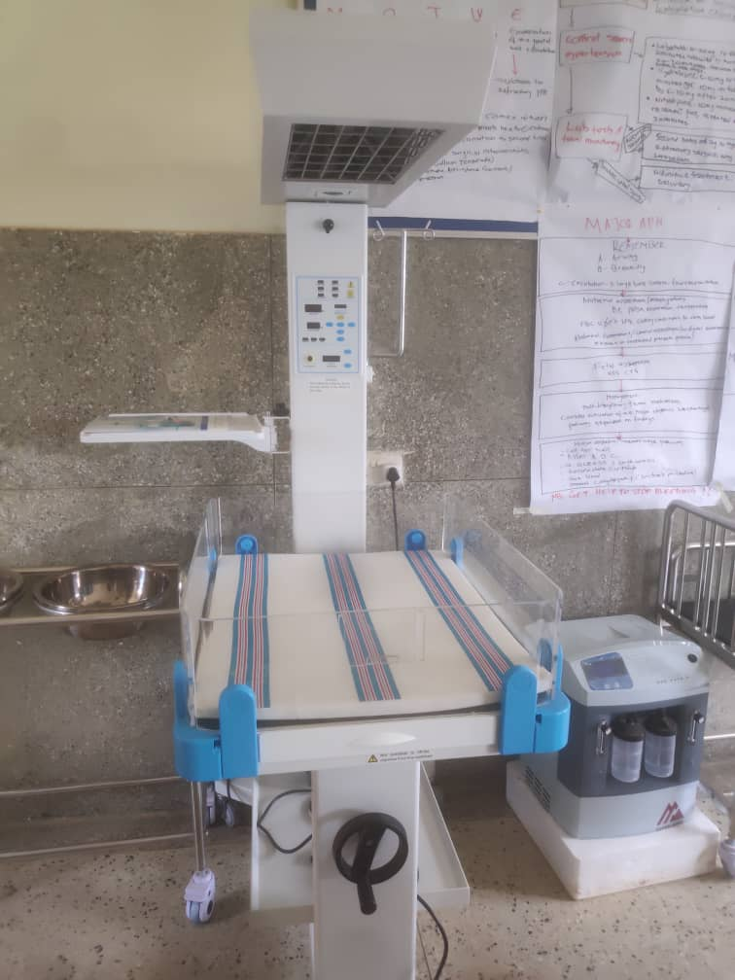
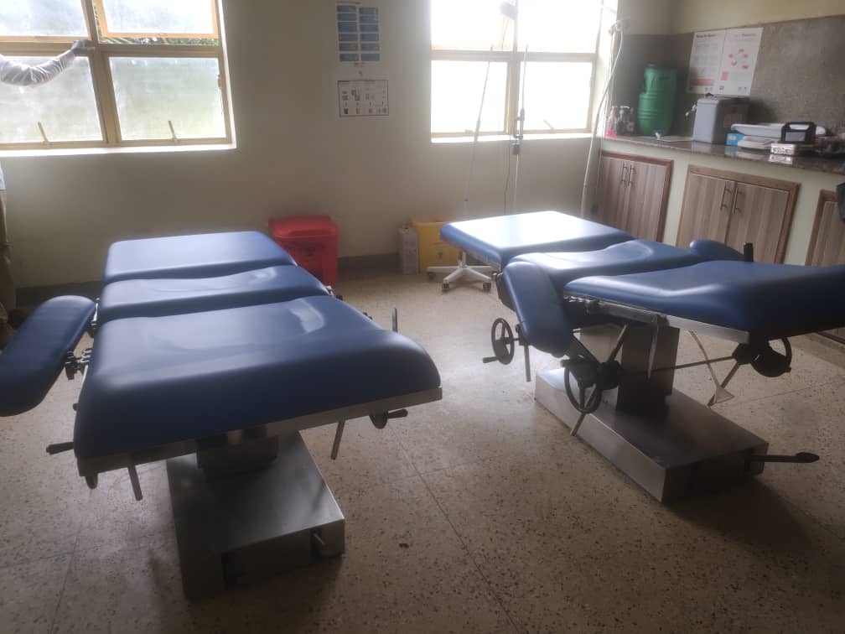

- ATYAK HC III — ZOMBO DISTRICT LOCAL GOVERNMENT (WEST NILE REGION)
Executive Summary
Atyak Health Centre III (Atyak HC III) in Zombo District Local Government underwent a physical asset verification and inventory audit on August 24, 2026. While the majority of the assets delivered are functional and actively improving patient service delivery, critical operational bottlenecks—specifically electrical power instability, undelivered asset packages, unboxed idle equipment, and a complete absence of physical engraving or financial cost tracking—require direct administrative intervention.
Findings
- None of the assets bear physical asset tag numbers or permanent engravings ("Not yet engraved").
- Undelivered Asset Items: ESR Stand: 1 unit missing/not delivered. Gas Stove: 1 unit missing/not delivered. MCH Diagnostic Equipment Set: 1 set missing/not delivered. Ward Hollow Ware Set: 2 out of 3 sets missing (only 1 set delivered).
- Damaged Furniture: 1 out of 3 office desks is missing its top wooden surface.
- Infrastructure Condition: The Non-Residential structure (OPD, Maternity, IPD, Lab, Latrines) is operational but was actively undergoing structural renovation during audit. Staff quarters are fully functional.
Facility Buildings
All primary non-residential, residential, and utility structures at Atyak Health Centre III are functional and actively utilized:
- Maternity, Inpatient & Laboratory Block – under renovation not operational during the verification visit
- Offices and OPD – Used as assets storage during the renovation
- Staff Quarters Block - 1 Residential Block
- Gentex Water Storage Tanks - 2 Units (5,000L each)
- Sanitation Facility - 1 Block (4-stance pit latrine)
Key Informant Insights
- The facility maintains manual and electronic logs tracking asset quantities received, though financial acquisition costs and net book values are missing.
Maintenance and Repair Framework:
- Major equipment is serviced on a scheduled basis by a technical maintenance team from Gulu Regional Referral Hospital. Minor maintenance is managed locally by facility staff.
- Operational status is monitored continuously by designated facility personnel and reported directly to the District Health Officer (DHO) and Gulu technical team.
Service Impact:
- UgIFT equipment has expanded health service capacity, increased outpatient and inpatient turnout, and bolstered community trust.
Challenges
- Power Supply Instability: Unreliable electrical power and power blackouts severely constrain the use of high-power medical equipment, including Oxygen Concentrators and Electric Suction Apparatus.
- Undelivered Supplies: Key clinical items on distribution lists remain undelivered.
Recommendations
- Power Infrastructure Upgrades: Install robust solar back-up power or voltage stabilization systems to guarantee continuous operation of oxygen concentrators and suction units.
- Delivery Follow-up: Coordinate with Zombo DLG and suppliers to retrieve outstanding equipment.
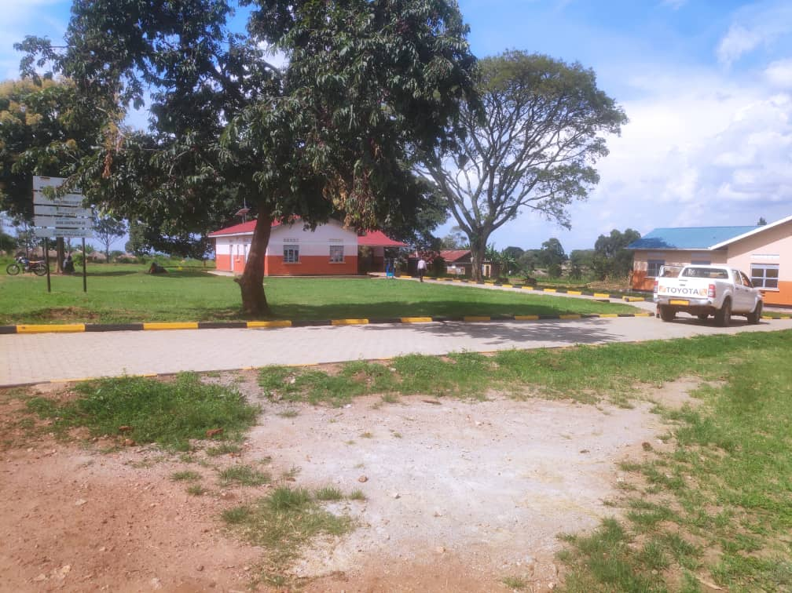
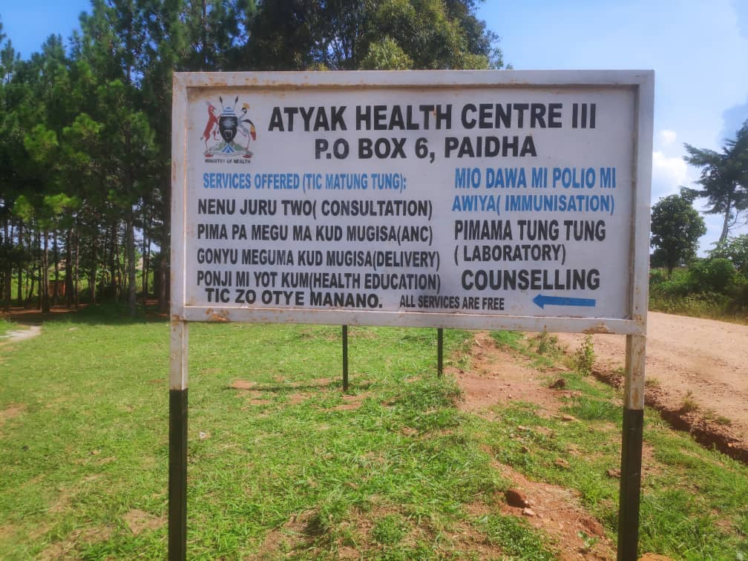
Field photos
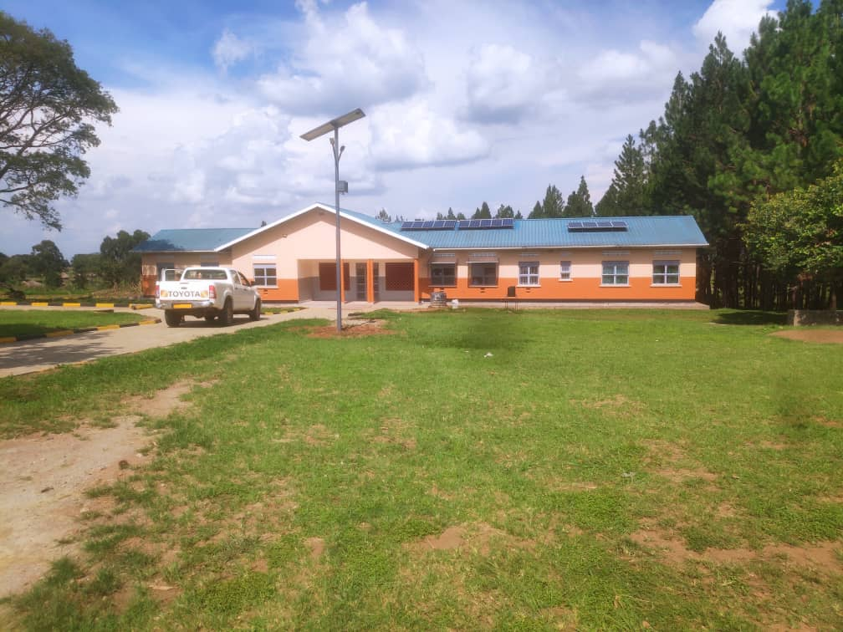

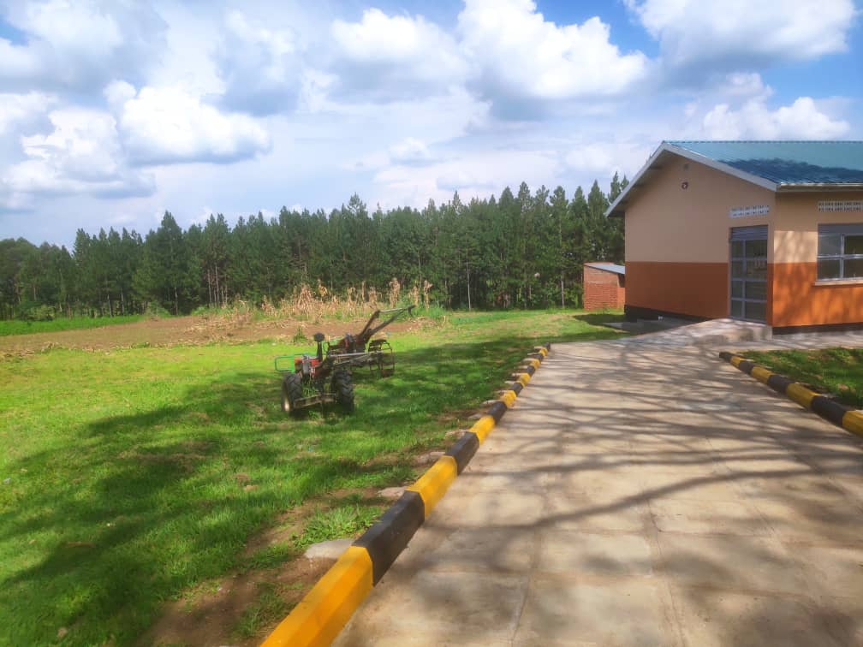
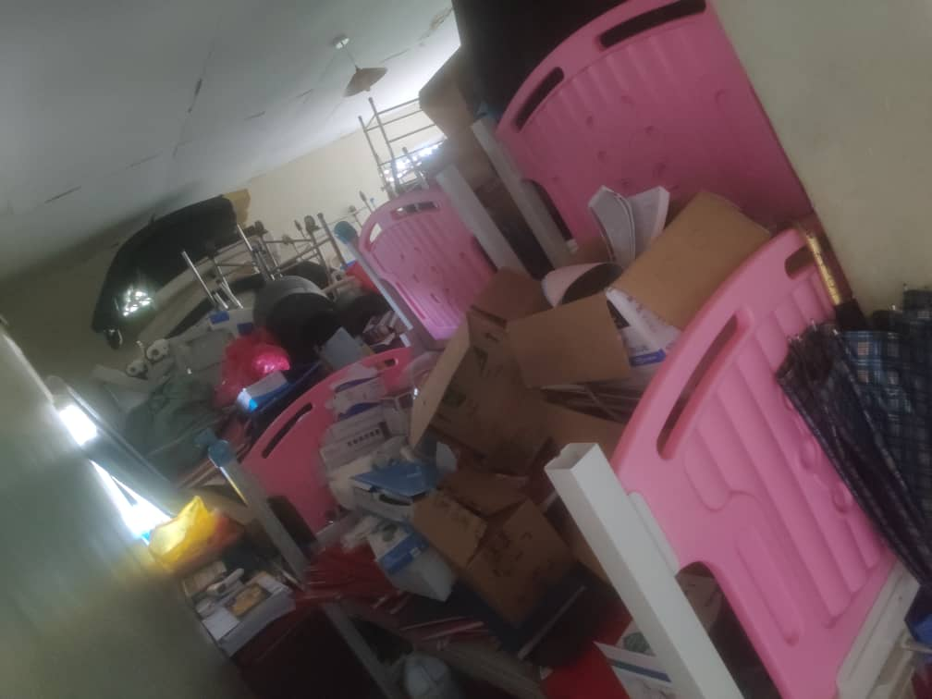
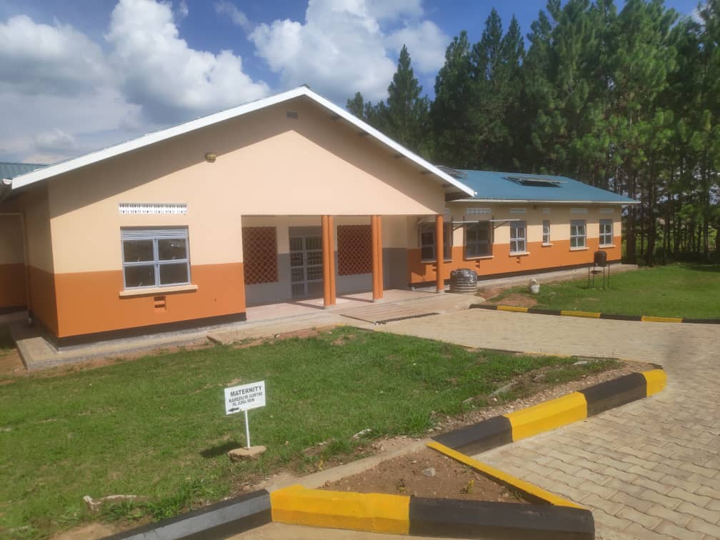

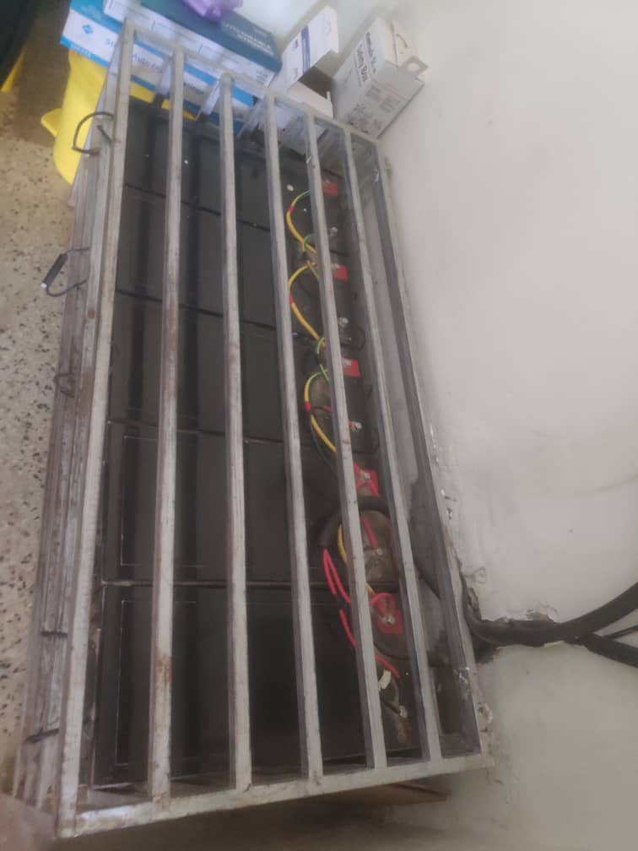
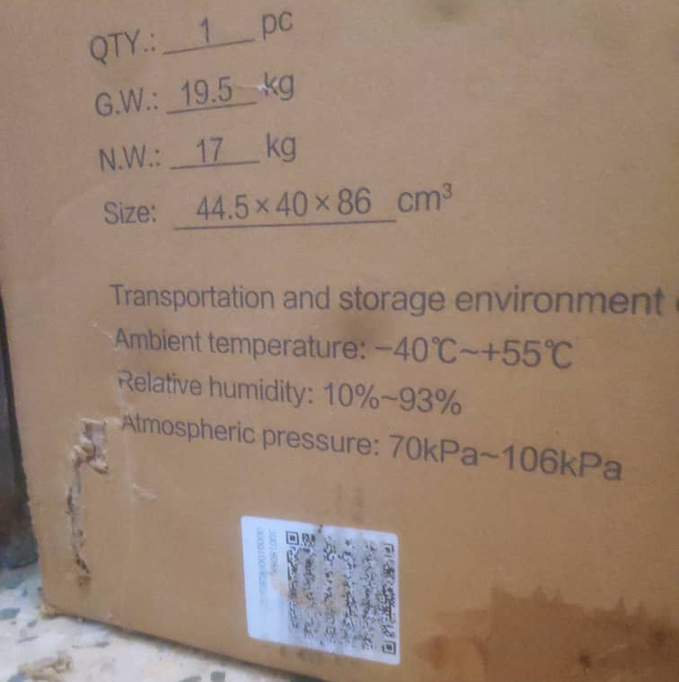
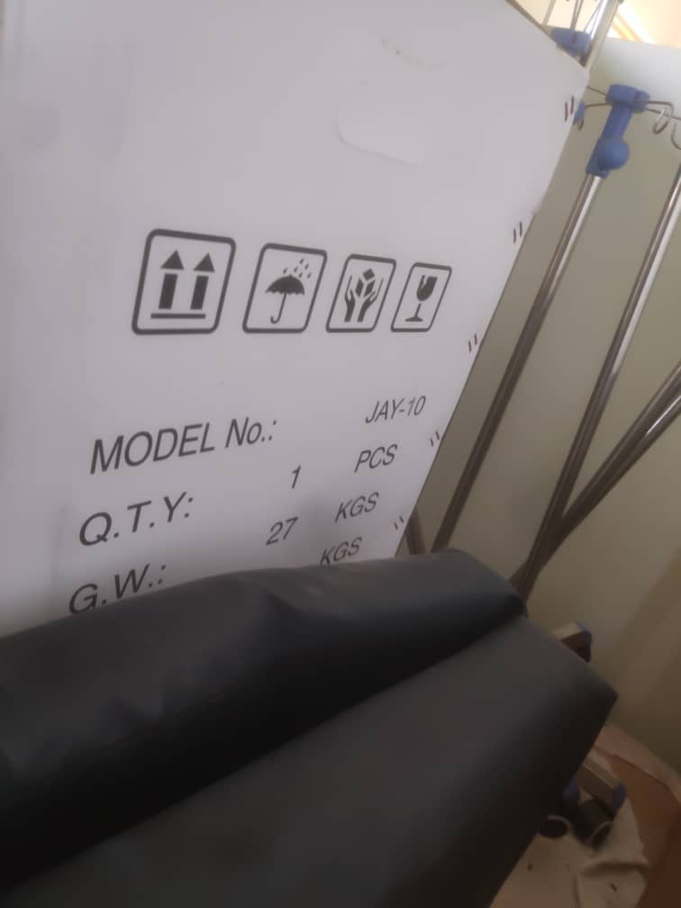

Report Compiled by:
Isah Lukwago and Stella Male

